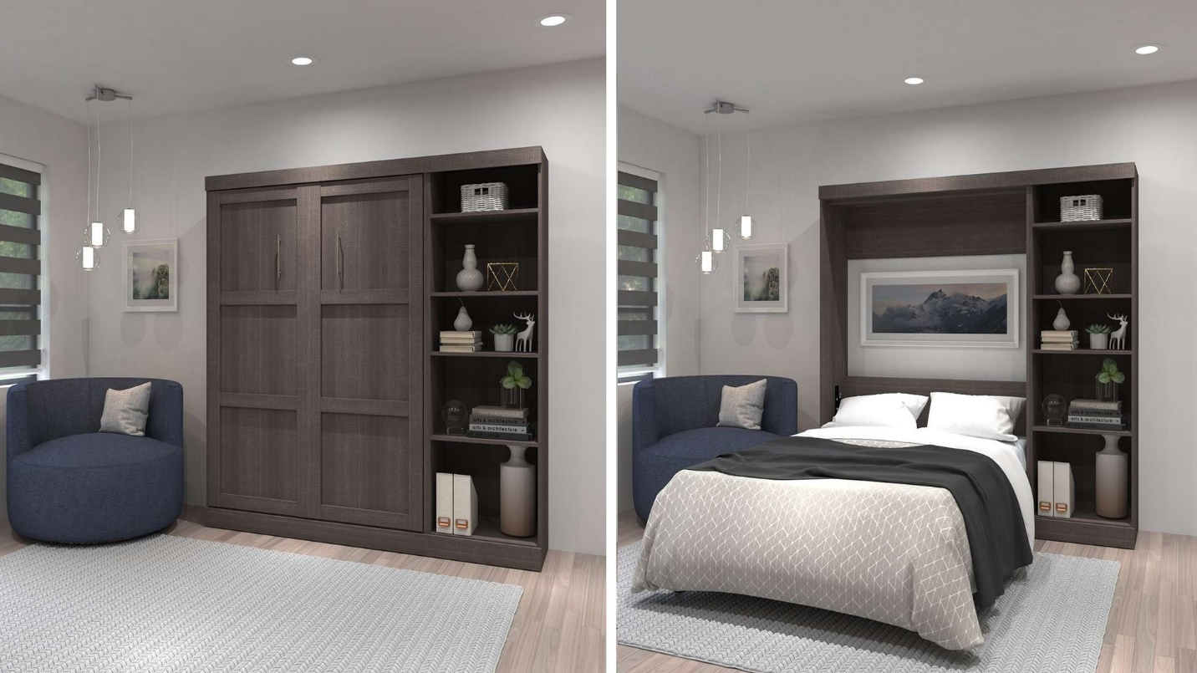

|  |  |
| --- | --- |
| **Title** | Full Wall Bed Kit |
| **Size** | 2.2 m long ; 1.9 m wide; 1.9 high |
| **Weight** | 136 kg |
| **Price** | $1,200.00 |